SIMPLE ALUMNI CONNECT & REFERRAL HUB
@CREATIVITY THINK (9483175986/7019689991)

ABSTRACT:
Simple Alumni Connect & Referral Hub is a web-based platform designed to connect alumni with current students, facilitate job referrals, and maintain an organized alumni network for colleges and training institutes. The system allows users to create detailed profiles, browse job and referral postings, send connection requests, exchange messages, and track referral status. Administrators can moderate user registrations, approve postings, monitor engagement metrics, send broadcast announcements, and export network statistics. Developed using Django and Django REST Framework for backend services, and React with Redux and axios for frontend interactivity, the platform ensures seamless networking, secure communications, and insightful analytics..

INTRODUCTION OF THE PROJECT:
Many colleges and training institutes struggle to maintain active engagement between alumni and current students. Traditional approaches such as email groups, social media pages, or offline events often fail to provide structured networking opportunities and measurable outcomes. Simple Alumni Connect & Referral Hub addresses these limitations by offering a centralized web platform that facilitates alumni-student connections, manages job and referral posts, tracks engagement, and provides analytics for administrators. The system enhances networking, improves career opportunities, and promotes active alumni participation..

PROJECT OBJECTIVES:

• Enable alumni and students to create and maintain detailed profiles
• Facilitate browsing and interaction with job and referral postings
• Allow users to send connection requests and track referral interest
• Provide messaging functionality for seamless communication
• Enable users to mark referrals as completed or pending
• Allow administrators to approve registrations and moderate content
• Track engagement metrics such as connections, referrals, and messages
• Broadcast announcements and export network statistics for reporting
• Enhance alumni engagement and institutional networking

PROBLEM OF THE STATEMENT:
Institutions often lack a structured system for managing alumni connections and referral processes. Existing methods are fragmented, inefficient, and difficult to track. There is no unified platform to facilitate networking, job referrals, or engagement analytics. This project addresses these challenges by offering a web-based hub that organizes alumni and student interactions, provides secure messaging, monitors engagement, and delivers actionable insights for institutional use..

MOTIVATION OF THE PROJECT:
• To build a centralized alumni-student networking system
• To streamline job referrals and professional connections
• To ensure secure, trackable communication between users
• To provide administrators with engagement analytics
• To promote alumni participation and knowledge sharing
• To enhance career support for current students
• To simplify moderation and content management
• To enable structured reporting and data-driven decision-making

BLOCK DAIGRAM OF PROJECT:

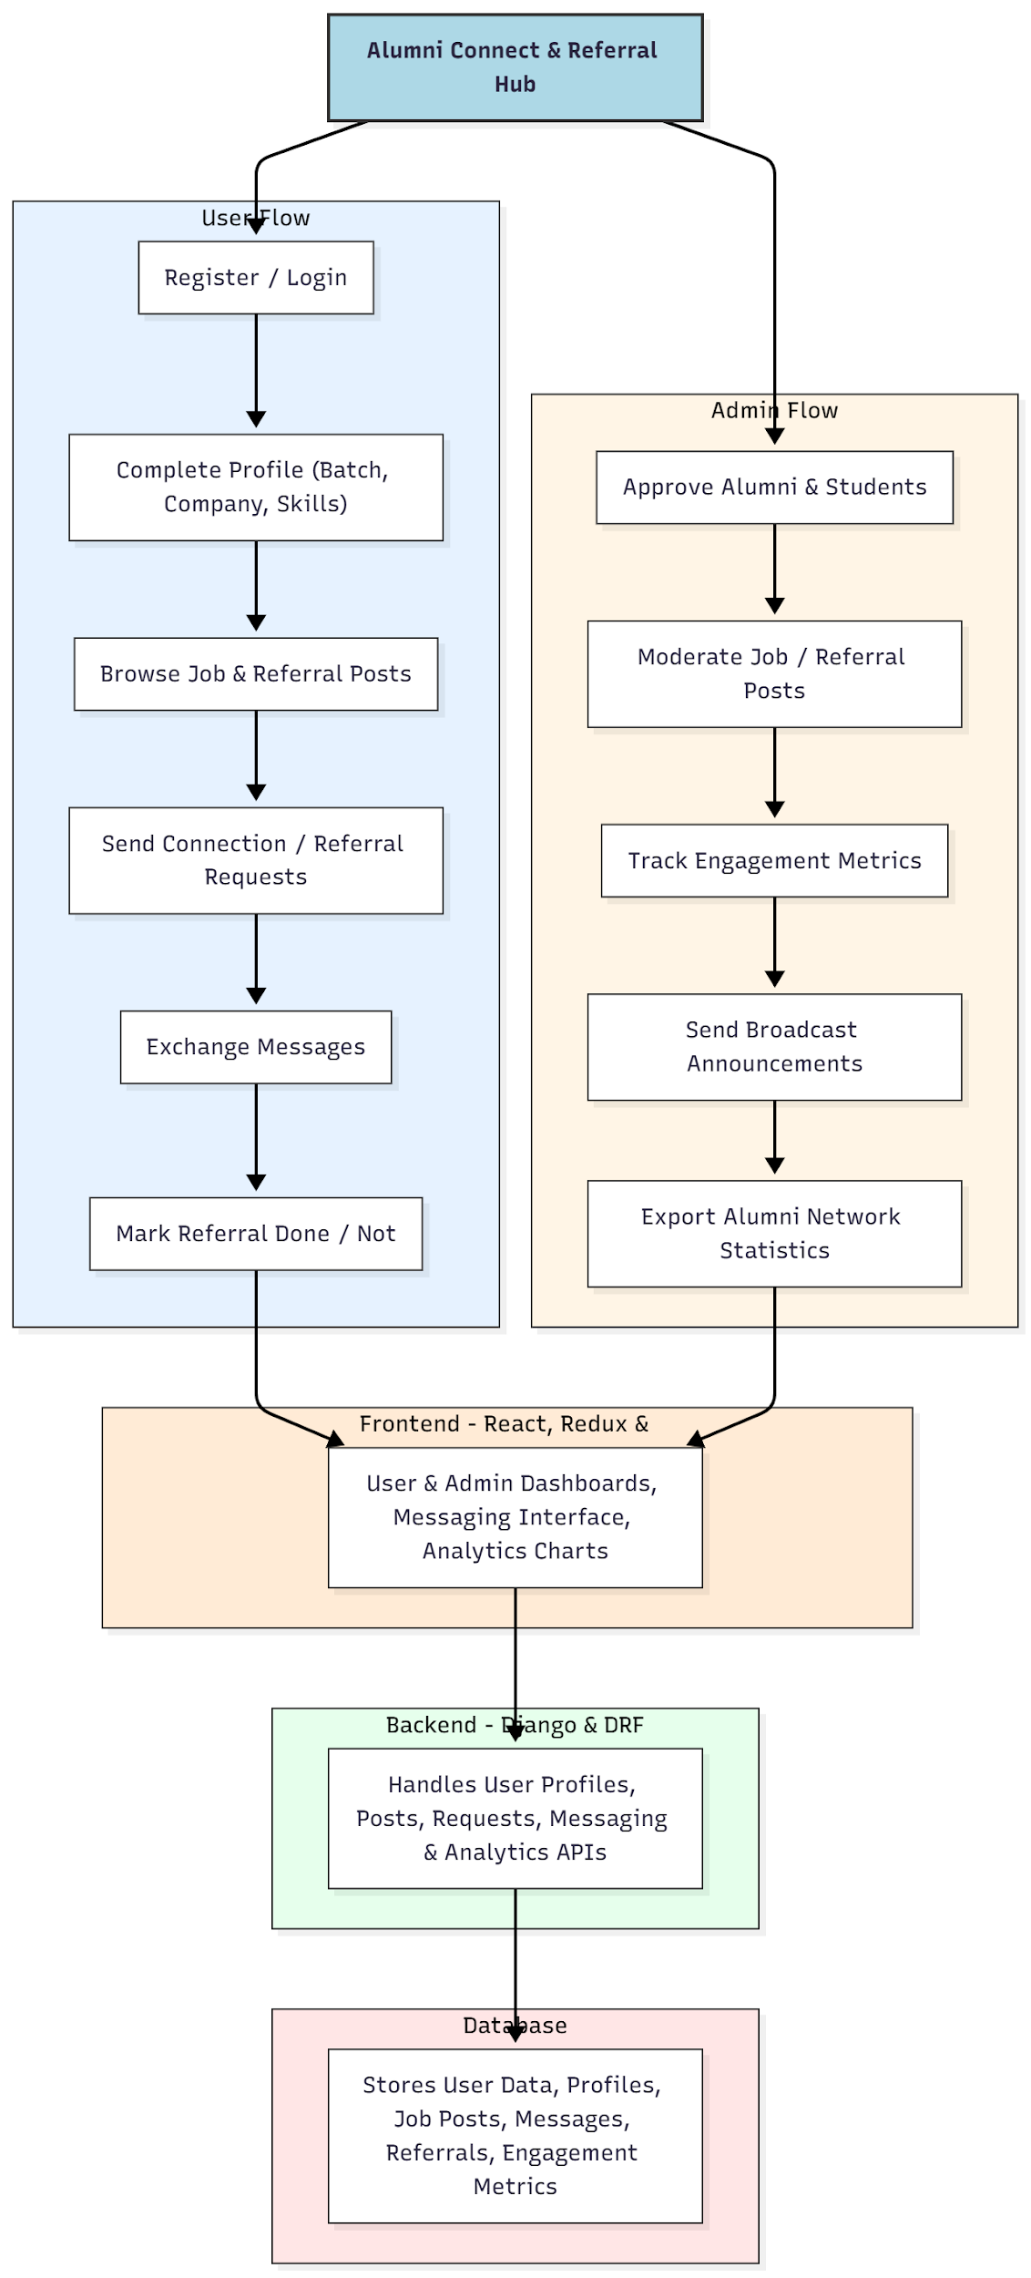

WORKING OF THE PROJECT:
Users start by registering and completing their profiles with batch, company, and skills information. They can browse job and referral posts, send connection or referral requests, exchange messages, and mark referrals as completed. Administrators approve user registrations, moderate job and referral content, track engagement metrics, broadcast announcements, and export network statistics. The backend processes all user actions, handles messaging and referral tracking, and manages analytics. The frontend provides interactive dashboards, charts, and messaging interfaces for both users and administrators, ensuring seamless networking and data-driven insights..

SOFTWARE REQUIREMENT:
- Backend:
  - Python 3.x
  - Django
  - Django REST Framework
  - SQLite/PostgreSQL
- Frontend:
  - Node.js and npm
  - React.js
  - Axios
- Development Tools:
  - Visual Studio Code
  - Postman (for testing APIs)
  - Git/GitHub (for version control)
- Server/Deployment (Optional):
  - Gunicorn, Nginx, or Heroku/AWS for hosting

ADVANTAGES OF THE PROJECT:

• Centralized alumni and student networking platform
• Streamlines job referrals and professional connections
• Provides secure, trackable messaging
• Offers analytics and engagement metrics
• Facilitates institutional communication through broadcasts
• Simplifies content moderation and reporting
• Improves alumni participation and networking
• Supports structured career support for students

APPLICATIONS OF THE PROJECT:
• College and university alumni networks
• Training institutes
• Student career support platforms
• Professional referral and mentorship programs
• Institutional engagement and analytics portals

REFERENCES:

- Django REST Framework Documentation — Django Software Foundation. Django Documentation. Available: https://docs.djangoproject.com/
- Django REST Framework. DRF Documentation. Available: https://www.django-rest-framework.org/
- React. React Official Documentation. Available: https://reactjs.org/docs/getting-started.html
- Redux. Redux Documentation. Available: https://redux.js.org/introduction/getting-started
- PostgreSQL Global Development Group. PostgreSQL Documentation. Available: https://www.postgresql.org/docs/
- MySQL. MySQL Reference Manual. Available: https://dev.mysql.com/doc/
- Git. Git Documentation. Available: https://git-scm.com/doc
- Node.js. Node.js Documentation. Available: https://nodejs.org/en/docs/
- Axios. Axios Documentation. Available: https://axios-http.com/docs/intro
- Socket.io Documentation – https://socket.io/docs/

